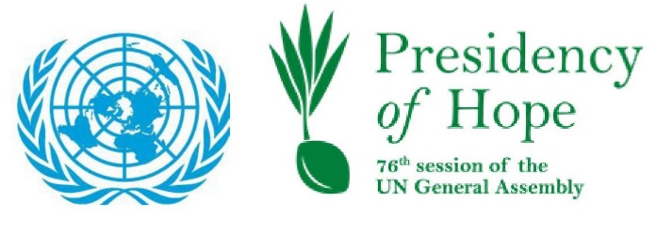
"Time to Act Together:
Coordinating Policy Responses to the Global Food Crisis General Assembly High-Level Special Event
18 July 2022

Remarks by H.E. Abdulla Shahid President of the UN General Assembly

I am pleased to co-convene this critical meeting on the global food crisis, in partnership with the Committee on Food Security.

I thank the Executive Office of the Secretary-General for its support in organizing the event.

The world faces a grave food crisis, as outlined by the recently released 2022 Report on the State of Food Security and Nutrition in the World.

Hunger and malnutrition are on the rise, with nearly a billion people going hungry in 2021.

This is a tragic reality brought on by a host of factors, including, COVID-19, climate change, and ongoing conflicts. These in turn have led to disrupted supply chains and inflation, driving millions into poverty.

The World Bank now warns us that the conflict in Ukraine will plunge an additional 95 million people into extreme poverty, and 50 million into severe hunger, this year.

As of June 30, 2022, the global Agricultural Price Index is estimated to be 34 percent higher than January 2021. Maize prices are 47 percent higher, and wheat prices 42 percent higher, compared to January 2021.

Our prospects of attaining SDG 2, a world of Zero Hunger, by 2030 look dim if we continue in this direction.

Frankly, we were already falling short of meeting our food-security targets, even prior to 2020. However, the situation is now critical. The shocks of multiple global crises have weakened our institutions, our economies, and challenged our ability to effectively respond.

In spite of this bleak picture, we cannot lose hope. Despair solves nothing. We must collectively mobilize to alleviate global hunger and malnutrition, and address the factors that cause them.

In this, the United Nations must take a leading role.

I fully support the Global Crisis Response Group on Food, Energy and Finance, launched by the Secretary-General, to provide joint analysis and policy recommendations from the whole of the United Nations System.

I also thank Member States for adopting resolution 76/264, entitled “State of global food insecurity”, urging the international community to jointly support countries affected by the food security crisis.

To further complement these initiatives, it is crucial that we involve all stakeholders, including major donors, international financial institutes, global and regional blocs, and civil society.

In our efforts, we must prioritize food-security in countries in special situations – LDCS, LLDCs and SIDS – whose citizens are typically forced to spend a larger share of their income on basic necessities, including food, and are thus disproportionately affected by rising food prices.

As we provide support to these countries, we must prioritize helping them implement the recommendations of the United Nations Food Systems Summit, on achieving sustainable transformations of their food systems.

We have long recognized that current food practices, in terms of production, consumption, and distribution, are unsustainable. They cause waste and inefficient distribution, while damaging our planet. If we continue on this path, we risk reduced crop yields and less available arable land in the future, threatening the food-security of not only ourselves, but of our children and grandchildren.

As we implement more sustainable and environmentally responsible food-practices, we must approach food security as part of a broader multilateral agenda. One that recognizes the interconnectedness of today’s challenges, and the futility of trying to solve them unilaterally or in isolation.

We need to ensure that our food systems can provide affordable healthy diets that are sustainable and inclusive, and become a powerful driving force towards ending hunger, food insecurity and malnutrition in all its forms, for all.

Among the actions that we must immediately take include scaling up climate resilience across food systems, strengthening food environments and changing consumer behaviour to promote dietary patterns with positive impacts on human health and the environment.

Solving food security also requires us to stop conflicts and pandemics that disrupt supply chains; to repair our relationship with nature, and secure sustainable agriculture; and to strengthen the global institutions working to alleviate poverty and hunger.

These are monumental yet necessary tasks. We will succeed only if we work together with solidarity, compassion, and resolve; with a sense of responsibility towards our most vulnerable; and with an urgent commitment to ensure that no one, anywhere should live their life in hunger, poverty, or insecurity.

I hope that our discussions today help us achieve our food security goals, and I wish you all a very productive discussion.

***

